Reading with the End in Mind:
A Dual Approach to Learning How to Read College-Level Texts
Susan Arvay, Assistant Professor, English
Raritan Valley Community College
susan.arvay@raritanval.edu

What’s in this handout?
Pages 3-4: National Assessment of Educational Progress (NAEP) Grade 12 reading scores for 2015
Pages 5-6: Sample handout for teaching critical reading (“getting” the text)
Pages 7-10: Sample handouts for teaching “connective thinking” (“using” the text)
Page 11: Sample essay prompts from PARCC Grade 11 ELA practice test
Pages 12-13: Sample essay prompts that promote critical thinking about texts
Page 14: Questions for discussion

OVERALL SCORE RESULTS

Average reading score for twelfth-grade students not significantly different compared to 2013
The 2015 average reading score for twelfth-grade students was not significantly different from the prior assessment in 2013; however, the 2015 score was lower in comparison to the average score in 1992, the first reading assessment year.
In addition to reporting scale scores, NAEP reports results at three achievement levels: Basic, Proficient, and Advanced. The cut score indicating the lower end of the score range for each achievement level is marked by a dotted line on the graphic below. Read a description of each achievement level by clicking its icon.
Trend in twelfth-grade NAEP reading average scores

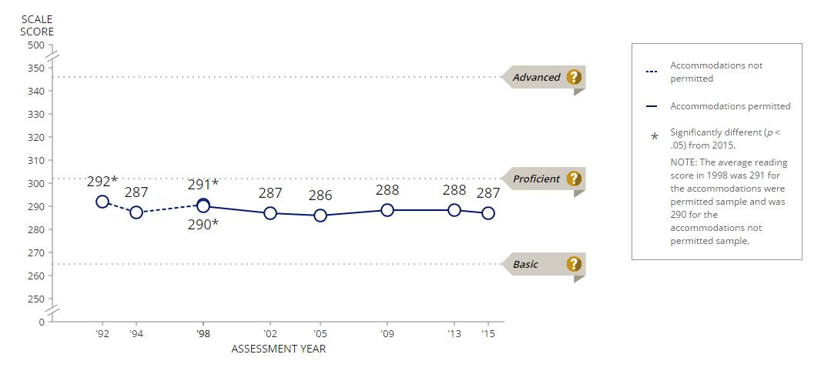
Advanced:
Twelfth-grade students performing at the Advanced level should be able to analyze both the meaning and the form of the text and provide complete, explicit, and precise text support for their analyses with specific examples. They should be able to read across multiple texts for a variety of purposes, analyzing and evaluating them individually and as a set.

Proficient:
Twelfth-grade students performing at the Proficient level should be able to locate and integrate information using sophisticated analyses of the meaning and form of the text. These students should be able to provide specific text support for inferences, interpretative statements, and comparisons within and across texts.

Basic:
Twelfth-grade students performing at the Basic level should be able to identify elements of meaning and form and relate them to the overall meaning of the text. They should be able to make inferences, develop interpretations, make connections between texts, and draw conclusions; and they should be able to provide some support for each. They should be able to interpret the meaning of a word as it is used in the text.

Source:
“2015 Mathematics and Reading at Grade 12.” The Nation’s Report Card. National Assessment of Educational Progress (NAEP), 27 April 2016. Web. 24 May 2016. http://www.nationsreportcard.gov/reading_math_g12_2015/#reading/scores

English Composition I with Workshop Arvay
How to be a Critical Reader
“Critical reading” means not just accepting what a text says without reflection. A critical reader will:
- analyze the claims and evidence that the author presents;
- identify the strengths and weaknesses of an argument;
- identify the assumptions that underlie an author’s argument;
- recognize both the explicit and the implicit arguments that an author is making;
- use ideas and evidence from one text to evaluate another text.
The following steps can help you to become a more critical reader.

Step 1: Pre-read
Briefly look through essay to get a sense of what it will be about. (Also read the information about the text and author at the bottom of the first page of every reading in TSIS.) Then think about what you already know about the author and/or subject. What do you expect from this author? What do you know about this subject?
- Why is this important? It prepares you for reading the text by calling on your prior knowledge of the author or the subject.

Step 2: Read the essay; look up vocabulary
Read slowly. Look up any words you don’t know and write the definition in the margin next to the word.
- Why is this important? It gives you a general sense of the reading. You learn any words you don’t already know.

Step 3: Re-read the essay; highlight and annotate
Re-read one paragraph at a time. As you go along, use a pen or pencil to underline, circle, or put a squiggle under these three things:
- the main ideas of the author’s “they say”
- the main ideas of the author’s “I say”
- important supporting examples from the author’s “I say.”
Whenever you identify a “they say” or “I say” main idea, briefly summarize it in your own words in the margin.
- Why is this important? It gives you a better understanding of the reading. It gets you started thinking about the author’s “they say” and “I say.”

Step 4: Identify the overall “they say” and “I say”
Using what you just did in Step 3, fill out the handout for Step 4, “Identifying an Author’s ‘They Say’ and ‘I Say.’” When you fill this out, focus on what you think is the main overall “they say” and “I say” in the essay.
- Why is this important? It helps you to figure out the author’s “they say” and “I say” in more depth.

Step 5: Summarize the author’s argument
Type a one-paragraph summary of the essay. Start with the author’s full name, the full title of the author’s essay, and the author’s “I say.” For example: “In the essay [title], the author, [name], argues that ___.”
Incorporate the author’s “they say” into your summary to give the author’s “I say” some context. (Remember the cartoons on pages 4 and 5 of TSIS. They show how context matters.)
Include several supporting examples that the author uses to back up his/her argument or “I say.” How does he/she respond to the “they say”?
Summaries are meant to objectively describe an argument, not analyze or critique it. Avoid your own personal opinion in the summary; stick to describing the author’s “they say” and “I say” in your own words.
- Why is this important? It helps you to see the author’s overall argument (the “I say”) in the context of the author’s “they say.” This helps you to decide what to write about for your own essays.

Credit where it’s due: This handout is based on the work of my colleague Karen Gaffney in the English department at RVCC.

English Composition I with Workshop Making Connections Arvay

Please take a few minutes to write your responses to the questions below. Be as specific as you can.

- Choose two quotations that you have included or plan to include in this paper, one from each reading. Copy them here:

- Circle the important words or phrases in each quotation.

- Choose one or two of the following phrases and fill in the blanks with words and ideas from the quotations.
____'s comment about ________ is a good example of______'s idea about______ because ______.

_____'s idea above is NOT a good example of_____'s idea about _______ because___________.

______'s idea above shows this problem with ________'s ideas:_________ because ________.

______’s discussion about ______ helps us to better understand _____’s claim about _______ because _______.

- Write for 20 minutes about the sentence you have just completed above. Explain it so that a reader unfamiliar with the two essays would understand it and why it is important. Write everything you can think of about that sentence and the quotations it refers to. Use another piece of paper if you run out of space.

- Reread what you wrote. Underline the best ideas. Cross out the sentences you won't be able to use.

- Make a list of the questions you still have about these quotations. Make your questions as specific as possible. Be ready to share them in class discussion.

English Composition I with Workshop Arvay

Comparison vs. Connection

In out-of-class essay #2, I’m asking you to find ways that Author #1 affects your reading of Author #2. In other words, I’m asking you to find ways that Author #1’s essay connects to Author #2’s essay. A connection is NOT the same thing as a comparison. Here are some examples using readings from the previous unit on obesity to help you see the difference:

Example #1 Using Engler and Schlosser:

On pages 175-176, Yves Engler observes that fast-food companies use lots of advertising aimed directly at children, and claims that this advertising contributes to people eating more and more junk food over the years.

Eric Schlosser, in his essay, explores in much more detail how fast-food companies work together with children’s entertainment companies like Walt Disney in order to market junk food to children. This cooperation between the fast-food and entertainment industries results in advertising that is very effective and very hard to avoid.

A comparison of Engler and Schlosser might say, “Engler and Schlosser both are concerned about fast food advertising aimed at children. They both think it’s harmful to children’s health.”

A connection between Engler and Schlosser might say, “Schlosser’s exploration of the ‘synergy’ between McDonald’s and Walt Disney helps us to better understand Engler’s concern about advertising aimed at children. Schlosser helps us to realize how pervasive this advertising is, and how deeply it’s woven into children’s everyday lives, which explains why Engler is so alarmed about it.”

►Take a moment to explain in your own words the difference between the comparison and the connection above:

Example #2 Using Engler and Campos:

Engler, like most of the authors in chapter 13, accepts that the obesity epidemic is real. He argues that the problem should be addressed through government intervention: increased regulation of the fast-food industry, government subsidies for healthy snacks like fruits and vegetables, and tax incentives to get people to exercise more.

Paul Campos questions whether the obesity epidemic is real at all by challenging the validity of the BMI chart, which is the currently accepted measure of obesity in America.

A comparison of Engler and Campos might say, “Engler assumes the obesity epidemic is real, but Campos disagrees and thinks that the epidemic is just a lot of ‘propaganda’ put out by the diet industry for its own profit.”

A connection between Engler and Campos might say, “Engler assumes that the obesity epidemic is so serious that we need the government to step in to solve the problem; however, Campos gives us a way to challenge Engler’s call for more government intervention in people’s lives by leading us to question if the obesity epidemic is real at all.

►Take a moment to explain in your own words the difference between the comparison and the connection above:

Now go back to your rough draft for paper #2 and look at the places where you bring the texts together to make your argument. Are you comparing the readings, or connecting them? Revise any comparisons so they become connections instead.

Sample essay prompts from the PARCC Grade 11 ELA Performance-Based Assessment Practice Test (available online at https://parcc.pearson.com/practice-tests/english/)
Prompt 1:
Now that you have read and answered questions about the passages from [Nella Larsen’s novel] Quicksand and [James Weldon Johnson’s] The Autobiography of an Ex-Colored Man, write an essay in which you identify a theme that is similar in both passages and analyze how each author uses the characters, events, and settings in the passages to develop the theme.

Prompt 2:
You have studied three sources involving the establishment of American independence from Great Britain. The sources are:
- “Declaration of Independence,” signed on July 4, 1776
- A passage from Patrick Henry’s March 23, 1776, “Speech to the Second Virginia Convention”
- The transcript of the video “From Subjects to Citizens”
An important idea presented in the sources involves the colonists’ notions of the purpose of government. Write an essay in which you explore the perspectives offered in the source documents regarding government’s purpose and its relationship to the people it governs. Use evidence from all three source documents to support your ideas.

Prompt 3:
Near the middle of paragraph 2 [in an excerpt from Nikolai Gogol’s “The Overcoat”], the author describes a “young man, a new comer” who shows sympathy for Akakiy. Write an imagined journal entry from the young man’s point of view as he reflects back on the situation later in life and the effects it has had on his life. Use what you have read in the passage to provide specific details relevant to the young man and Akakiy
Sample essay assignment for English Composition I at Raritan Valley Community College using They Say/I Say with Readings (3rd ed.)

Texts to work with: Your choice of any two of the following from They Say/I Say with Readings:
- Sanford Ungar, “The New Liberal Arts” (226-233)
- Gerald Graff, “Hidden intellectualism” (264-271)
- Mike Rose, “Blue-Collar Brilliance” (272-284)
- Charles Murray, “Are Too Many People Going to College” (234-254)

For this assignment, I’d like you to make an argument about how reading one essay affects your reading of another essay. Instead of asking yourself which essay is more persuasive, you should ask yourself: How can one essay help me better understand another essay? Or, what does one essay reveal about another essay?

You should make an argument about the specific way that text #1 shapes your reading of text #2. For example:
- Does text #1 give you reasons to see that the argument in text #2 is valid? OR
- Does text #1 give you reasons to question the argument made in text #2? OR
- Does text #1 help you to better understand the argument made in text #2?

Sample essay assignments for Expository Writing 101 at Rutgers using The New Humanities Reader (2nd ed.)

In “The Roots of Debate in Education and the Hope of Dialogue,” Deborah Tannen argues that Western culture is an “argument culture” (582) in which truth and knowledge are thought of as arising from contentious debate rather than from “integrative thinking” (594). This tendency to value argument in which opponents attack and undermine each other’s positions shapes not only the way we’re taught in school but, according to Tannen, ultimately “threaten[s] our system of governance” (598) and contributes to “the breakdown in human connections” (601-602). In other words, the way we think about truth and knowledge has ripple effects throughout our whole society.

For this paper, I’d like you to use Tannen and any one other reading we’ve discussed this semester to explore the implications of how we know what we know. Does the other author that you choose approach problems “agonistically” by employing “rigid dichotomies” (596) or does this author employ a more “integrative” method to understanding and solving them? How does their approach help and/or hinder this writer’s ability to deal with these problems?

Both David Abram and Chris McCandless see themselves as engaged in a kind of spiritual quest that takes them away from civilization and into the heart of “uncivilized” nature. For your second paper I’d like you to consider the nature and significance of their quests, and how McCandless’s story, related by Jon Krakauer in Into the Wild, helps us to rethink parts of Abram’s argument.

Does McCandless’s story and other people’s reaction to it complicate Abram’s understanding of how the West approaches the natural world? To what extent does Abram’s explanation of the West’s attitude toward nature help us understand Chris McCandless’s motives for doing what he did?
Some questions you might consider: Is the West more spiritually dependent on the natural world than Abram thinks? Is McCandless a kind of “Western shaman”? How so or how not?

Questions for discussion:

What do you expect your students to do with texts as writers?

How do you teach them to read for this purpose?

What kinds of texts do you assign them to write about? How do these texts help them to achieve the writing goals you’ve set for them?

What are some of the ways we would like students to read? What kinds of texts and writing assignments can cultivate these ways of reading?

